Tuning Box

Installation instructions

Porsche 3.0l & 3.6l V6
SENT

Installation: about 30 Min

Safety Tips
Before installing this device, read the installation instructions carefully and follow our instructions and recommendations. Do not start with the installation before you have read and understood the instructions.

These operating instructions are based on the example of a vehicle model. Deviations from the individual models are possible.

German warranties apply. The company does not assume any liability for personal injury or property damage resulting from failure to observe these operating instructions.

Attention!

Important information

Technical Supplier
If you have any questions or suggestions regarding this installation, feel free to call us from Monday till Saturday between 09:00am - 05:00pm CET.
Supplier Number: +

Preliminary
The Tuning Box is specifically tuned and programmed for your vehicle. Due to production tolerances, the result of the Performance can higher or lower.
Also, the performance increase may vary depending on the maintenance condition and mileage of the vehicle.

If the performance is too high, shown by a strong soot formation, disturbed engine run, the engine misfiring or the initiation of the engine emergency manifests itself. A software adjustment of the pre-setting is possible. Please contact the supplier.

Preparation for installation
Remove the ignition key from the vehicle, open the bonnet, close the doors and lock the vehicle. Now wait 2-3 minutes (on most vehicles you will hear a clear "click" in the engine compartment) until the timer function of the engine control unit is switched off.

If necessary, remove the engine cover and other parts so that you can locate the rail pressure sensor or intake manifold pressure sensor / charge pressure sensor.

Installation
ATTENTION
Before disconnecting the sensors, you must disconnect the battery. If you don’t do this, an error may occur in the engine control unit.

Arrows: position of the sensors
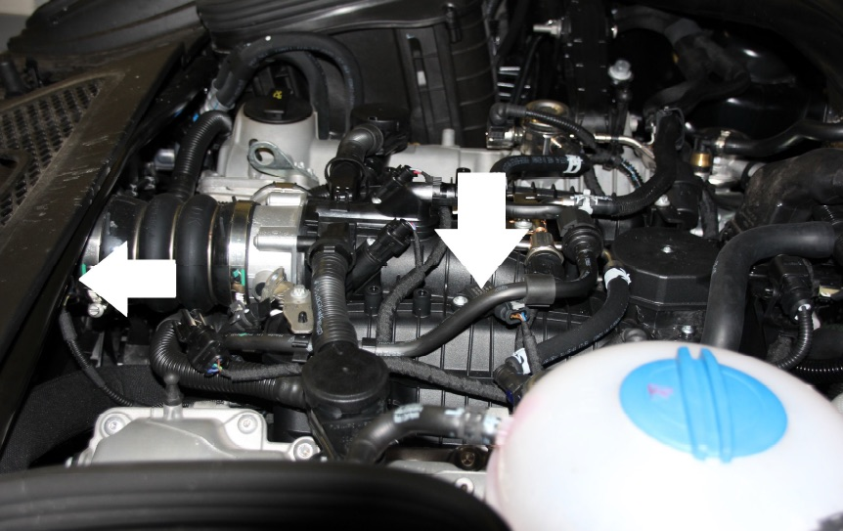

Open the plugs on the sensor(s) and insert the cable set between the original plugs.

The rail pressure connector is 3-pole and is located at one of the ends or in the middle of the rail depending on the vehicle type.

The intake manifold pressure sensor and/or boost pressure sensor is 3 or 4-pin and is located on the intake manifold or pressure hose, depending on the type of vehicle.

Make sure that the safety catch, which holds the two plugs together, closes.

Connector shape may differ depending on the vehicle.

Connector shape may differ depending on the vehicle..

Please be sure to keep enough distance from hot parts of the engine (exhaust gas recirculation, turbocharger, exhaust manifold, etc.) when installing and fixing the cable with cable ties and the Tuning-kit.

Connect the control unit with the cable set.

The control unit must be installed at a suitable location, protected from water and vibration, away from the engine where it is protected from splashing water or other corrosive liquids (e.g., battery acid fumes). In the case of damage caused by improper installation of the Tuning kit, the Company will void all test and replacement claims.

The team wishes you a lot of fun and a great trip!

Troubleshooting

1. "The engine does not start."
- Check once again all the connected components: Are the connectors properly locked or connected to the correct sensors?
- Has a plug been twisted connected? If possible.
- Is the LED functioning correctly?

2. "The engine bucking or doesn’t run smoothly."
- Check once again all the connected components: Are the connectors properly locked or connected to the correct sensors?
- A software adjustment of the presetting is possible. Please contact the supplier.

3. "Engine immediately runs in fail-save program (The Malfunction Indication Light (MIL) flashes in the Instrument Cluster)."
- Check once again all the connected components: Are the connectors properly locked or connected to the correct sensors?
- Has a plug been twisted connected? If possible.
- You may have opened the sensors while the engine control unit has not been turned off. Delete the errors in the engine control unit and restart the engine.

4. "The fail-save program runs in higher RPM."
- Check once again all the connected components: Are the connectors properly locked or connected to the correct sensors?
- A software adjustment of the presetting is possible. Please contact the supplier.

5. "The engine does not show any extra performance."
- To achieve maximum performance, use a higher-octane fueled (98 ROZ or higher).
- A software adjustment of the presetting is possible. Please contact the supplier.

6. "The engine produces too much soot."
- A software adjustment of the presetting is possible. Please contact the supplier.

